Name___________________________________. Mark= /

|  |  |  |
| --- | --- | --- |
| Test part | Possible mark | Your mark |
| Multiple choice | 27 |  |
| Short answer | 18 |  |
| Extended answer | 10 |  |
| Total | 55 |  |

**Inheritance, Variation, Primates and Hominins.**

***Multiple choice answer sheet. Shade in the one answer you think to be best.***

|  |  |  |
| --- | --- | --- |
| ⒈ Ⓐ Ⓑ Ⓒ Ⓓ  ⒉ Ⓐ Ⓑ Ⓒ Ⓓ  ⒊ Ⓐ Ⓑ Ⓒ Ⓓ  ⒋ Ⓐ Ⓑ Ⓒ Ⓓ  ⒌ Ⓐ Ⓑ Ⓒ Ⓓ  ⒍ Ⓐ Ⓑ Ⓒ Ⓓ  ⒎ Ⓐ Ⓑ Ⓒ Ⓓ  ⒏ Ⓐ Ⓑ Ⓒ Ⓓ  ⒐ Ⓐ Ⓑ Ⓒ Ⓓ  ⒑ Ⓐ Ⓑ Ⓒ Ⓓ | 11 Ⓐ Ⓑ Ⓒ Ⓓ  12 Ⓐ Ⓑ Ⓒ Ⓓ  13 Ⓐ Ⓑ Ⓒ Ⓓ  14 Ⓐ Ⓑ Ⓒ Ⓓ  15 Ⓐ Ⓑ Ⓒ Ⓓ  16 Ⓐ Ⓑ Ⓒ Ⓓ  17 Ⓐ Ⓑ Ⓒ Ⓓ  18 Ⓐ Ⓑ Ⓒ Ⓓ  19 Ⓐ Ⓑ Ⓒ Ⓓ  20 Ⓐ Ⓑ Ⓒ Ⓓ | 21 Ⓐ Ⓑ Ⓒ Ⓓ  22 Ⓐ Ⓑ Ⓒ Ⓓ  23 Ⓐ Ⓑ Ⓒ Ⓓ  24 Ⓐ Ⓑ Ⓒ Ⓓ  25 Ⓐ Ⓑ Ⓒ Ⓓ  26 Ⓐ Ⓑ Ⓒ Ⓓ  27 Ⓐ Ⓑ Ⓒ Ⓓ |

1. Which of the following statements about the move to an agricultural lifestyle by Humans is **FALSE**?
2. Its long term affect was an increase in population numbers.
3. It caused people to move from hunter gathering lifestyles.
4. It is first seen with Homo erectus.
5. It is not seen in all parts of the world.
6. Fire and advanced tool culture allowed which of the following?
7. Less impact of environmental selective pressures on Hominins and greater manipulation of the environment by Hominins.
8. More impact of environmental selective pressures on Hominins and greater manipulation of the environment by Hominins.
9. Greater predation on Hominins.
10. Less impact of selective pressures on Hominins and less manipulation of the environment by Hominins.
11. Which of the following lists the primates in order of evolution, going from simple to more complex.
12. Old world monkeys, Lemur, new world monkeys, apes and Humans.
13. New world monkeys, Old world monkeys and apes.
14. Old world monkeys, new world monkeys and lemurs.
15. Apes, Lemurs, monkeys and Humans.
16. Which of the following will have the largest olfactory centre relative to total brain size?
17. New world Monkey
18. Old world Monkey
19. Homo erectus
20. Lemur
21. Which of the following is **not** true of Homo erectus?
22. It had a sloping forehead compared to Homo sapiens.
23. It was able to live in colder climates than Homo habilis.
24. It had a similar cranial capacity to Homo neanderthalensis.
25. It had pentadactyl hands.

6 Look at this diagram of a type of stone tool.

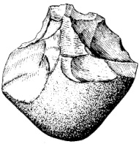

The name of this type of tool and the organism associated with it are:

1. Acheulean and Australopithecus.
2. Spear and Jackson and Homo sapiens.
3. Oldowan and Australopithecus and Homo habilis
4. Mousterain and Homo habilis.
5. Which of the following have the lifestyle paired with the correct organism?

a. Hunter gatherer and Homo erectus.

b. Scavenger gatherer and Homo erectus.

c. Agriculture and Australopithecus.

d. Scavenger gatherer and Homo neanderthalensis.

1. Which of the following statements about Homo erectus is **NOT** correct?

a. Their geographical distribution was wider than Homo habilis.

b. They were able to have more of an impact on the environment than Homo habilis.

c. They were not as able to clear land as Homo habilis.

d. They were more able to reduce the amount of parasites in meat than Homo habilis.

Read this article and use it to answer the questions that follow.

In 1912, Charles Dawson, an amateur palaeontologist, found what was thought to be an early human skull. It was named “Piltdown Man”. It was believed to be a very ancient human. It was popularly referred to as "the missing link" in human evolution. In 1949, the Piltdown bones were finally tested for fluorine content and a fraud became apparent. The skull and jaw clearly were not from the same time period. This has since been backed up by C14 dating. It consisted of a 700 year old human skull (cranium) bones, a 500-year-old lower jaw bone of an [orang-utan](http://en.wikipedia.org/wiki/Orangutan) and [chimpanzee](http://en.wikipedia.org/wiki/Chimpanzee) mineral fossil teeth. The bones had originally came from different sites and been reburied together.

9. Which of the following is most likely to be true?

1. The Jaw would have contained more Fluorine than the Skull bones.
2. The skull bones would have contained more Fluorine than the jaw.
3. The skull and jaw bones would have had the same fluorine content.
4. There is not enough information in the article above to determine which bone would have the most fluorine.

10. Which of the following is **FALSE?**

1. The chimpanzee teeth could be C14 dated.
2. The Jaw bone could be C14 date.
3. The skull bones could be C14 dated.
4. The chimpanzee teeth could not be C14 dated.

11. If Piltdown Man had been an earlier human ancestor his prognation would have been:

1. Greater than modern humans.
2. Greater than modern Lemurs.
3. Less than modern humans.
4. Undeterminable from the evidence above.

Read this article and use it to answer two the questions that follow.

In 1996, excavation of a Neanderthal cave site uncovered, what some claim to be, the section of a flute made from the femur bone of a young bear. The artefact is dated between 60,000 to 50,000 years old, making it possibly the oldest musical instrument ever found.



12. This artefact shows that:

1. Neanderthals had religious beliefs.
2. Neanderthals played on the first Jethro Tull album.
3. Neanderthals had bear cults.
4. Neanderthal tools were fine enough to cut holes in bone.

13. This artefact could be absolute dated using:

1. Carbon C14 dating.
2. Fluorine dating.
3. Stratigraphy.
4. A form of radio isotope dating other than carbon C14 dating.

14. Which of the following is TRUE?

1. Melanin is made in melasome tissue by melanocytes.
2. Melanin is made in Melanocytes by melasome organelles.
3. Melanin is absorbed from the sun.
4. Melanin production stops in winter.

15 Kevin is blood type AB. This means that he can accept blood donated by people who are blood type:

1. AB only.
2. O type only.
3. A type or B type.
4. Any blood type.

Use the diagram below to answer question 16.

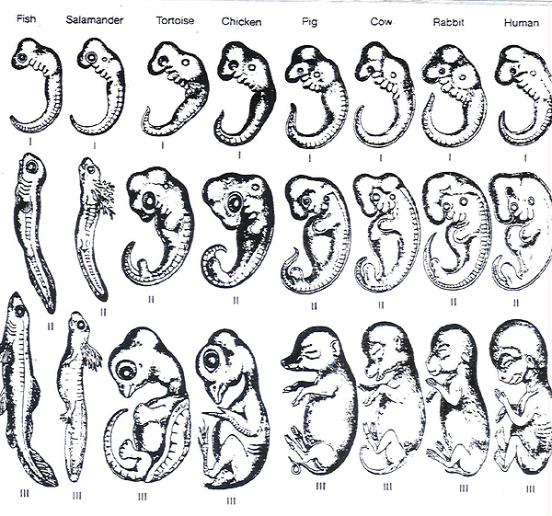

16. The diagram above shows a method of comparing different organisms to see if they share a common evolutionary ancestor. The method is known as:

1. Comparative anatomy.
2. Comparative embryology.
3. Comparative evolution.
4. Comparative selection.

17. In fruit flies with the curly wing mutation, the wings will be straight if the flies are kept at 16 degrees Celsius. The most probable explanation for this is that

1. fruit flies with curly wings cannot survive at high temperatures
2. the environment influences wing phenotype in these fruit flies
3. height temperatures increases the rate of mutations
4. wing length in these fruit flies is directly proportional to temperature
5. The antibodies that a baby receives from its mother in breast milk are an example of:
6. Natural passive immunity.
7. Artificial passive immunity.
8. Natural active immunity.
9. Artificial active immunity.

19. Vaccination using attenuated antigens is an example of:

1. Natural passive immunity.
2. Artificial passive immunity.
3. Natural active immunity.
4. Artificial active immunity.

Use the diagram below to answer questions 3 and 4.

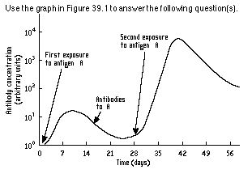

20. Why does the antibody concentration between 21 and 28 days **not** drop back to zero?

1. Memory T cells carry antibodies able to respond to antigen A.
2. Killer T cells carry antibodies able to respond to antigen A.
3. Memory B cells carry antibodies able to respond to antigen A.
4. Plasma B cells carry antibodies able to respond to antigen A.

21. The response to antigen A at 28 days would result in:

1. A rapid response and little or no symptoms of infection.
2. A reduction in T cells, but an increase in B cells.
3. Similar symptoms as seen in days 0 to 14.
4. A new set of antigens being produced.

22. Genetic drift is:   
  
a. a change in gene frequencies caused by random events.     
b. a change in an allele due to alterations in the DNA molecule.     
c. a change in gene frequencies due to exchange of genes between different populations.     
d. a product of natural selection.

23. The presence of a high tryglicerates among French Canadians in Quebec because of a high incidence in the early population of the provinces is an example of:   
  
a. genetic drift.     
b. gene flow.     
c. natural selection.     
d. the founder effect.

24. Tay-Sachs disease is due to any of several mutant alleles. One possible explanation for its prevalence in Ashkenazi populations is that the alleles provide resistance to:

1. Tuberculosis.
2. Sickle cell anaemia.
3. Malaria.
4. Small pox.

25. In 1550 AD 60% of the population of the village of La Pont in France were killed by an outbreak of Plague. This altered the allele frequency of the village. This is an example of:

1. Random genetic drift.
2. Founder effect.
3. Genetic bottleneck.
4. Sociocultural isolation.

26. Agglutination can best be described as:

a. a process where antibodies cause antigens to stick together in clumps.

b. a process where antibodies cause pathogen cell membranes to break.

c. a process where macrophages engulf virus particles.

d. a process where antibodies stop virus particles replicating.

27 . A body cell becomes infected by virus particles. The body would respond by:

a. sending antibodies to neutralize the virus.

b. sending Killer T cell white blood cells to attach the infected cell.

c. sending Plasma B cells.

d. sending macrophages to engulf jus the virus particles.

Short Answer Section

1. Complete this table

|  |  |  |
| --- | --- | --- |
| Type of leucocyte | Where is it produced? | Where does it mature? |
| B cell |  |  |
| T cell |  |  |

1. marks)
2. Write definitions for the words in the table below.

|  |  |
| --- | --- |
| Word | Meaning |
| Antigen |  |
| Antibody |  |

(2 marks)

1. What is opsonisation?

________________________________________________________________________________________________________________________________________________________________________________________________________________________________________________________________

(3 marks)

1. Sickle cell anaemia (uh-NEE-me-uh) is the most common form of sickle cell disease (SCD). SCD is a serious disorder in which the body makes sickle-shaped red blood cells. “Sickle-shaped” means that the red blood cells are shaped like a crescent.

Normal red blood cells are disc-shaped and look like doughnuts without holes in the centre. They move easily through your blood vessels. Red blood cells contain an iron-rich protein called haemoglobin (HEE-muh-glow-bin). This protein carries oxygen from the lungs to the rest of the body.

Sickle cells contain abnormal haemoglobin called sickle haemoglobin or haemoglobin S. Sickle haemoglobin causes the cells to develop a sickle, or crescent, shape.

Sickle cells are stiff and sticky. They tend to block blood flow in the blood vessels of the limbs and organs. Blocked blood flow can cause pain and organ damage. It can also raise the risk for infection. It also reduces the amount of oxygen being carried in the body

1. Sickle cell anaemia is caused by a recessive allele. Why would this allele normally be removed from the gene pool?

________________________________________________________________________________________________________________________________________________________________________________________________________________________________________________________________

(2 marks)

1. Why has Sickle cell anaemia not been removed from the gene pool?

______________________________________________________________________________________________________________________________________________________________________________________________________________________________________________________________________________________________________________________________________________________________________________________________________________________________________________________________________________________________________________________________________________________________________________________________

1. marks)

5. Write definitions for all of the words in the table below

(3 marks)

|  |  |
| --- | --- |
| Term | Meaning |
| Arboreal |  |
| Bipedal |  |
| Pentadactyl |  |

6.The Amish (pronounced 'Aahmish') are an American Protestant group with around 200,000 members descended from about 3000 European people who came to the USA more than two centuries ago to escape persecution. They tend not to marry people outside of the Amish community.

Certain alleles have a higher frequency in the Amish community compared to the original European population and the wider population of the USA.

Give reasons for this difference in allele frequency. Use all of the correct terms, explaining each.

(10 marks)

________________________________________________________________________________________________________________________________________________________________________________________________________________________________________________________________

________________________________________________________________________________________________________________________________________________________________________________________________________________________________________________________________

________________________________________________________________________________________________________________________________________________________________________________________________________________________________________________________________

________________________________________________________________________________________________________________________________________________________________________________________________________________________________________________________________

________________________________________________________________________________________________________________________________________________________________________________________________________________________________________________________________

________________________________________________________________________________________________________________________________________________________________________________________________________________________________________________________________

________________________________________________________________________________________________________________________________________________________________________________________________________________________________________________________________

________________________________________________________________________________________________________________________________________________________________________________________________________________________________________________________________

________________________________________________________________________________________________________________________________________________________________________________________________________________________________________________________________

_______________________________________________________________________________________________________________________________